Epi InfoTMuser’s guide

Inter-country operational research on all-oral shorter treatment regimens for rifampicin-resistant tuberculosis

2020-2021

|  |  |  |
| --- | --- | --- |
| **Version** | **Date** | **Description of changes** |
| V1 | 20-Mar-2020 | Original version |
| V2 | 22-Mar-2020 | Information about generation of participant ID and recording into “Screening and enrollment log” and CRF added (page 8)  Section added about how to rename and file CRF soft copies and hard copies (page 16) |
| V3 | 12 July-2020 | Data dictionary updated due to change of content of database |
|  |  |  |
|  |  |  |

Opening the data entry form



1. To launch Epi Info™ 7, click the icon on your computer desktop or find the program from the start pop-up menu.
2. From the Epi Info™ main screen click "**Enter Data**" button. The Enter Data window will open

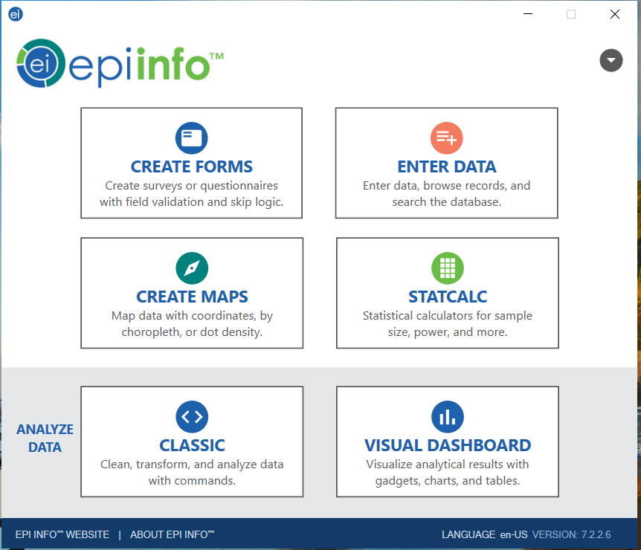

1. Open the data entry form by clicking the **Open Form** button on top right corner or by selecting **File->Open Form**

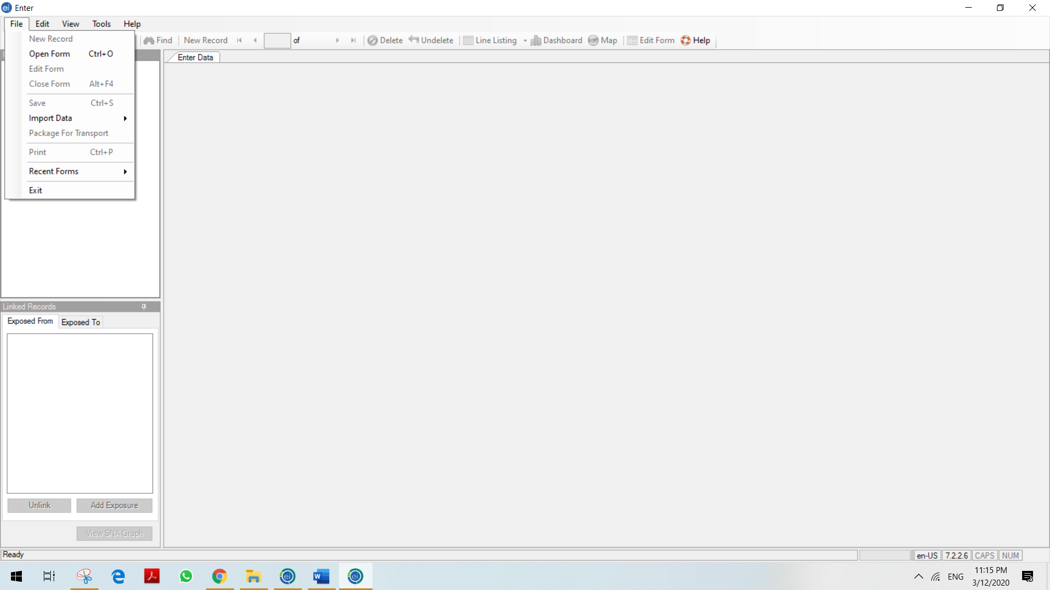

1. Click the **Browse** button to browse for an Epi Info™ 7 project

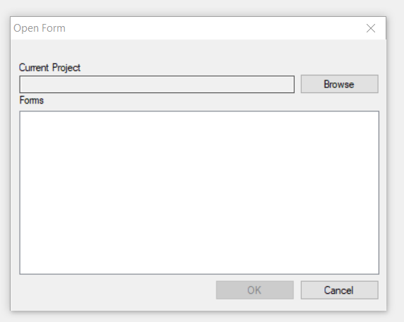

From the site that you save the tool file, locate the **Study_March14_RUS - BEL\Study**.prj project directory. Select the **Study. prj** and click **Open** to open it.

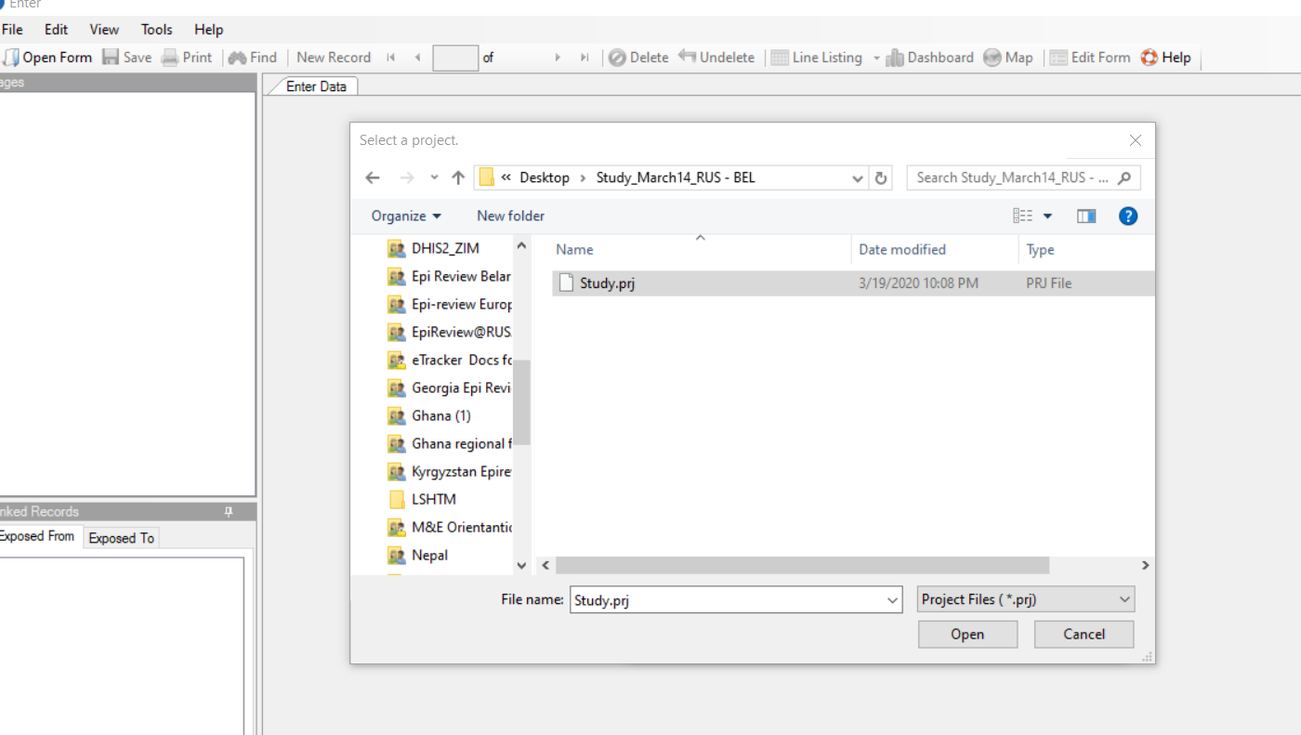

From new window “Data table properties” give your preferred name to the table (here Belarus_mSTR) and click OK. Note that the table name should be without space. By default, records ID will start from 1.

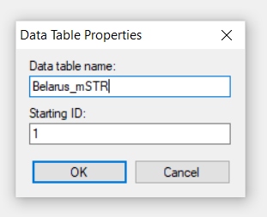

NOTE 1: Screening forms shall not be entered into the database. Data entry shall be done only for patients who were enrolled into study and were assigned **Participant ID.**

NOTE 2: All patients (including those screened) shall be recorded in “***Subject Screening and Enrollment***” logbook. Because this logbook contains patient identifiers’ (Name, Last name) only limited number of study team members shall have access to this document. Logbook should be password protected and kept confidentially. Logbook will be used to link patient name with participant ID, monitor the progress of study enrolment and status of the patients.

# Entering data

Place the **cursor** in the first data entry field.

1. There are six types of variable format in this tool: Numeric, text, date, checkbox, drop-down options and yes/no options. For detailed descriptions of each variable, please refer to the data dictionary at the end of this document. Please be advised that any space that is left blank or unselected will be considered and shown as “missing data” when extracting the database, therefore please make sure you enter all the information before data
2. As an example, a drop-down list (e.g. countries) allows you to select an item from a list. In this tool, options of drop-down list might be selected just by entering the related numeric value.

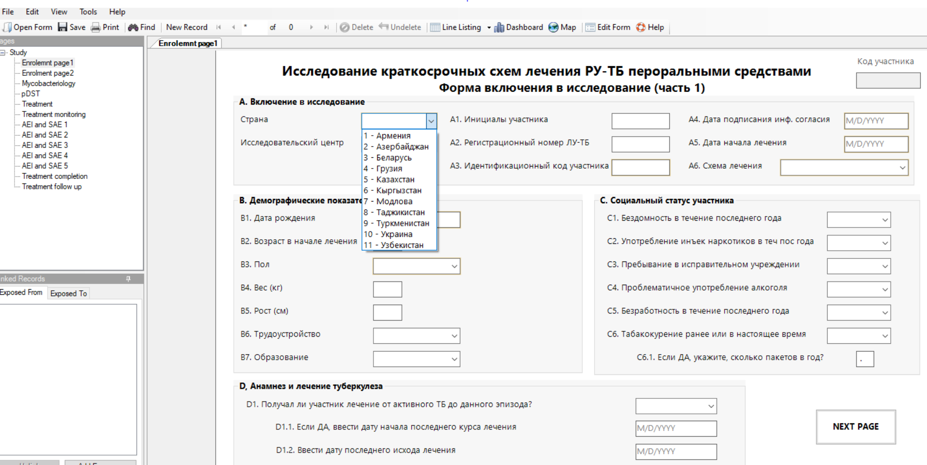

1. Text boxes (e.g. Initials) allows you to enter a single line of text.

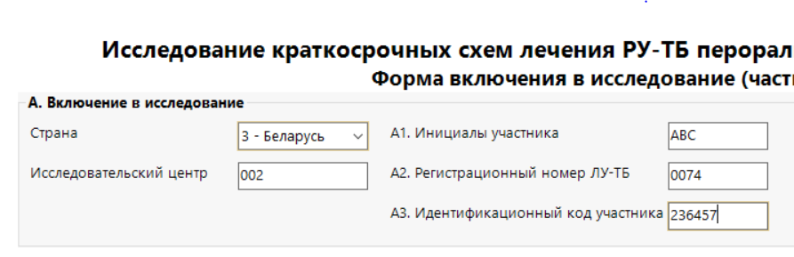

Numeric field enter data from another tool

Text field enter data from another tool

1. The date box (e.g. Date of start of treatment) allows you to select a date from a pop-up calendar.

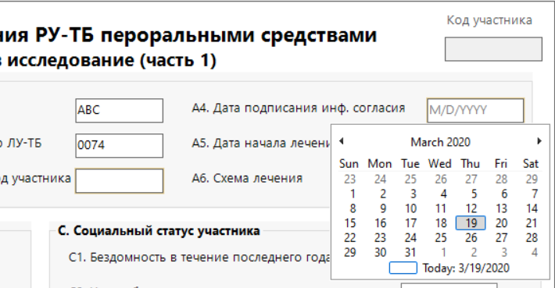

Use the arrows to navigate between months enter data from another tool

To navigate between year to year click on the name of the month twice (to see yearly calendar) and three time to see 10-yearly calendar.

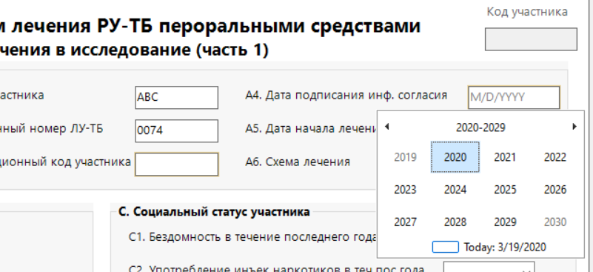

Use the arrows to navigate between years. data from another tool

1. Numeric boxes (e.g. Weight) allows you to enter a number. Observation boxes allows you to enter multiline text.
2. No navigate from one field to another field you can press **Enter OR Tab OR navigate by mouse.**

NOTE 1: Date formatting M/D/YYYY or D/M/YYYY depends on computer setting. To set desired setting, please revise your computer settings. In screenshots of current guide M/D/YYYY is demonstrated. Any option is fine for study.

1. After entering data on the first page, click **Page options** on the right to enter data on different page

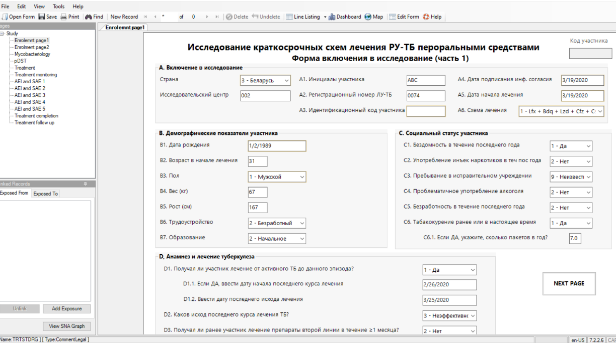

Click on page options to navigate between pages data from another tool

OR click on NEXT PAGE button to go to second page from another tool

NOTE1: There are field that are required to enter (e.g.) Treatment start date. If you keep it blank, the record could not be saved. You will have a warning message



NOTE 2. Age field (page 1) is calculated automatically once you enter Treatment start date and Date of birth

NOTE 3. There are field that are disabled, based on conditions entered in previous fields. Thus, the if the sex of patient is male, then the field “*Is patient pregnant?”* will be disabled.

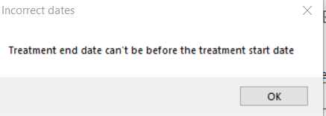NOTE 4. In case of inconsistent data entry, you might receive a warning message as in the picture below:

NOTE 5. There are mirror fields, which reflect the field already completed. For example on each page you can see Participant ID at right upper corner, which is linked to the field on the first page.

NOTE 6. Participant ID is the Epi Info generated consecutive number of the record. Once the patient data are entered into Epi info, the system assigned participant ID should be manually entered into designated field, recorded on hard/electronic versions of CRF and communicated back to the clinician to record it in “Subject screening and enrollment log” and ensure that all further records contain participant ID.

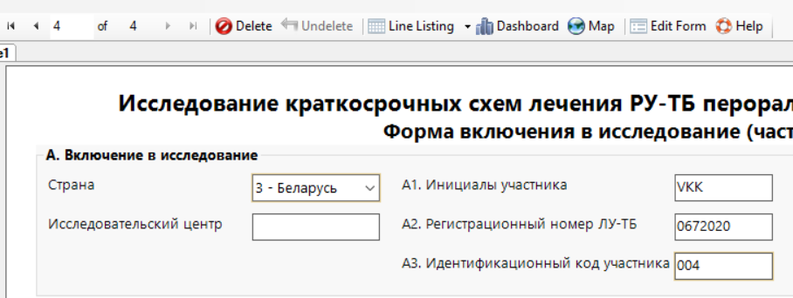

System generated ID shall be entered manually into corresponding field tool

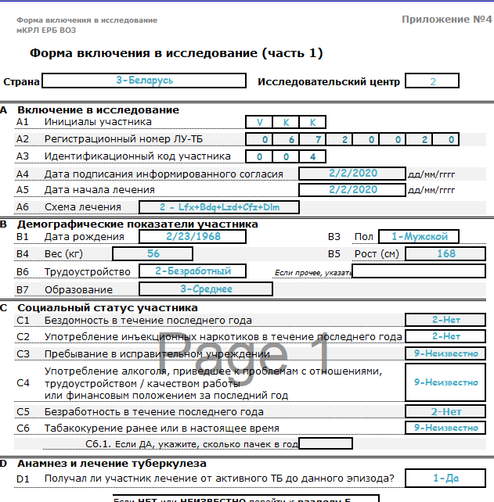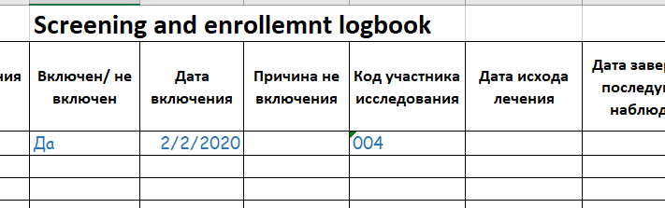

System generated participant ID shall be entered into “**Subject screening & enrollment logbook**” tool

Participant ID shall be recorded in all forms of **CRF** (both hard and soft copy)

As data are entered, the cursor moves from field-to-field, page-to-page, and saves data as you move to a new page.

Use the **Tab** or **Enter** key to move to the next field.

**When you want to stop your data entry, follow these steps:**

1. Go to File in the menu at the top of the page;

2. Choose "Save". If you want to stop all data-entry:

3. Choose "Exit" from the File menu and you will return to the main Epi Info™ page.

Entering Mycobacteriology data (page Mycobacteriology)

On the first column enter the month since start of the treatment from the clinical evaluation form

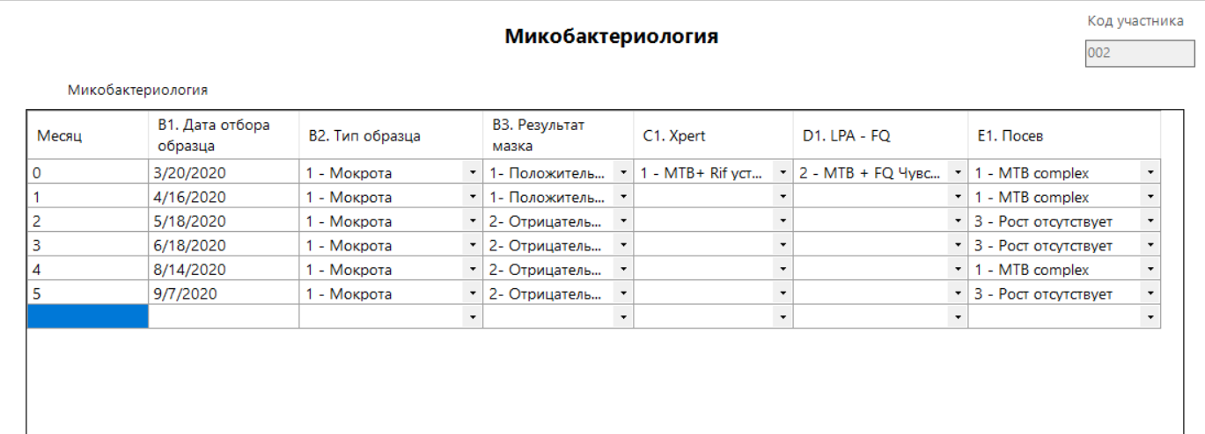

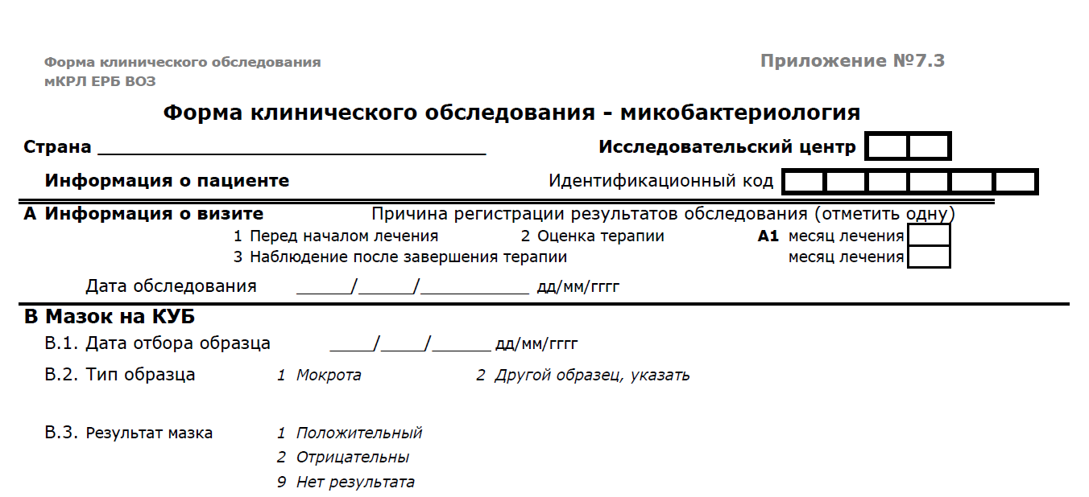

***5***

***07 09 2020***

For each of new evaluation date new row shall be opened. You can enter any number of rows to record laboratory examinations. Likewise enter DST data.

Entering treatment data (page Treatment)

In the first column in each of the row select all drugs in the treatment regimen. In the second column enter the data of start of treatment and then doses taken in relation to administered doses. The source of this data is Individual treatment card.

If any of the drugs in the regimen is interrupted and replaced with another medicine, enter the end date of the given medicine and from the new row enter name of new medicine, date of start and dose taken each of month.

The results shall be entered regularly, upon their availability.

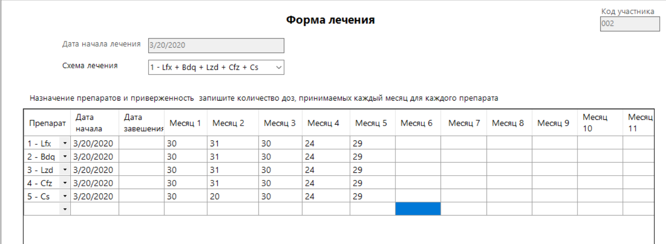

Entering SAE and AEI data

1. AE shall be entered in a chronological order. In the current tool up to 5 SAEs per patient might be entered.
2. In the grid suspected drug using drop-down list enter all drugs in the treatment regimen.
3. Select relevant fields “Actions taken”, “Events diminished after drug stopped”, “Event reappeared after drug re-introduced” etc. for each drug.

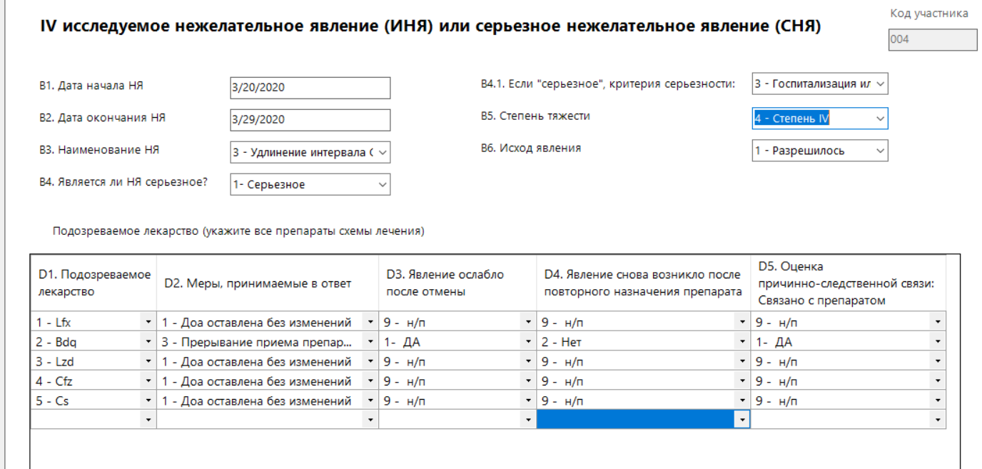

# Saving data and entering a new record

1. Epi info automatically saves data as you move from page-to-page. You can also save data manually by clicking **Save or File->Save** after finishing entering a record.
2. To enter a new record, click **New Record** from the toolbar to open a new record.

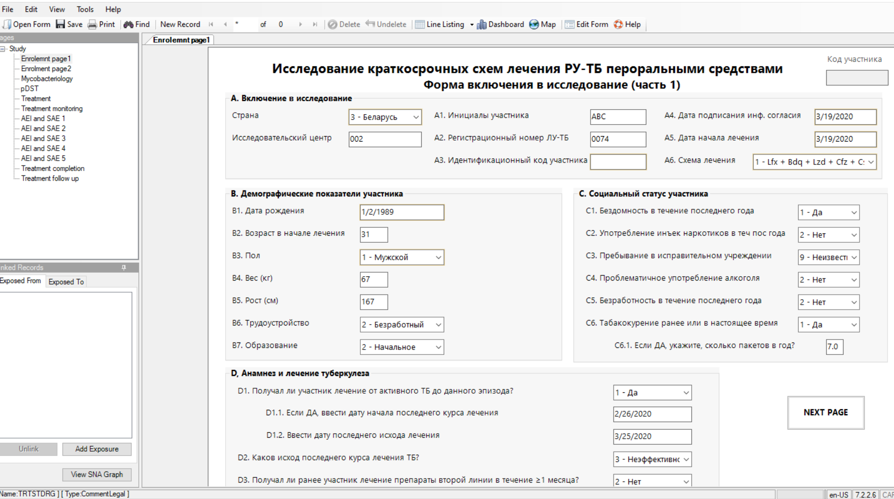

# Finding or editing records

Periodically might need to find specific record to enter new data which will become available over the treatment progress (new laboratory test result, uptake of treatment, treatment outcome).

1. Enter a record number to find a specific record or click to navigate to different records



Last record

Next

First record

Total number of records in the form

Currently on record number

Previous

Find can search for a record matching any field value or combination of field values. Advanced search features can be used in the Find window. To Find Records Matching a Specified Criteria:

1. From the toolbar, select the **Find** icon. The Find Records window open.
2. Select one or more field names from the Select Search Fields section.
3. Enter search criteria and click **Search**. Results appear in a grid in the Find window.

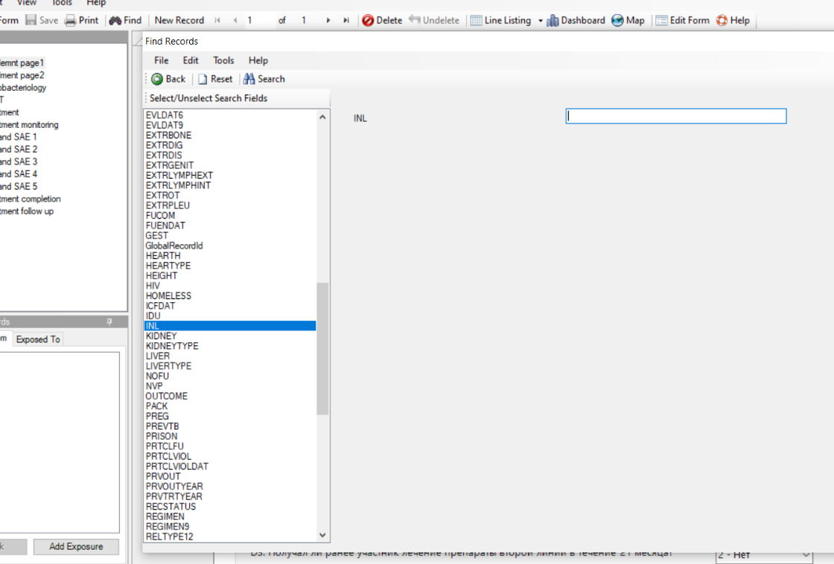

3.Click search

2.Enter search criteria

1.Select field names you are using to search specific record

* Click**Reset** to begin a new search. Note that more than one field can be searched at a time.
* Click **Back** to return to the Enter workspace

1. Open a record by double-clicking the **arrow**on the chosen row. The record displays in the Enter Data workspace

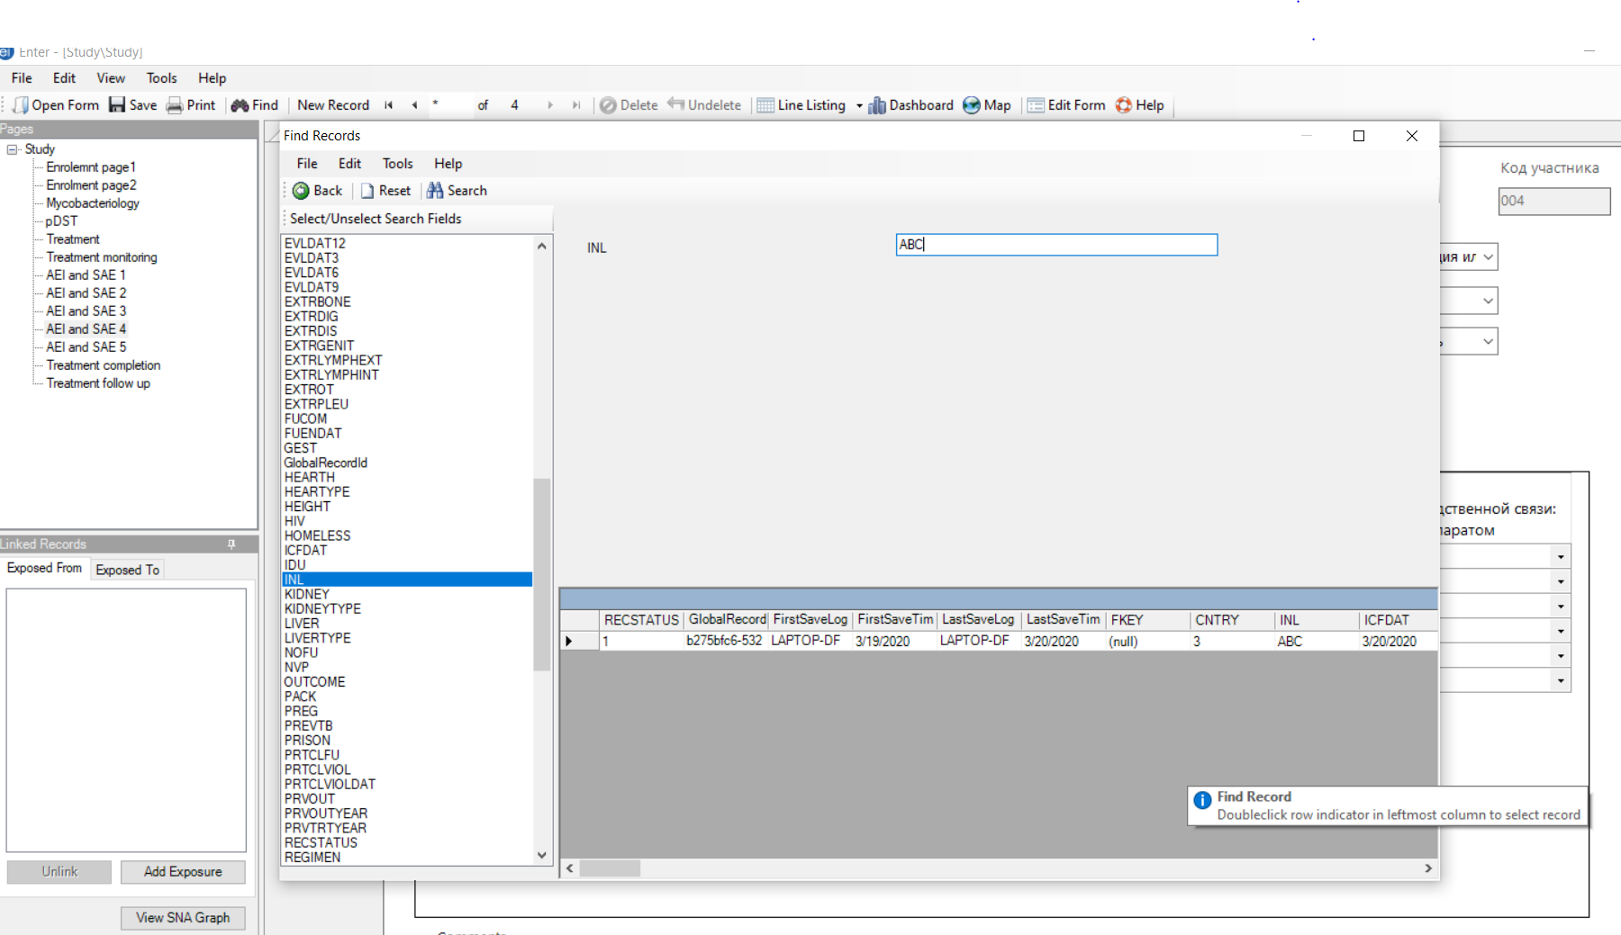

1. Please remember to manually save the record after editing, Epi-InfoTM may not automatically save the edited records.
2. Click **Line Listing** to see all data that has been entered. Click **Delete** if you want to delete a record.

# Back-up

The copy of the database shall be saved weekly in the different folder of the user’s computer and on a hard drive. Alternatively, you can save it in the cloud: (Any of following: One drive, Drop box, Google drive). First create copy of the folder with Project file then rename of as country name_studysite_date. E.g. **Ukraine_002_12092020**

# Filing and storage of CRFs

All electronic copies of CRFs shall be renamed as Participant ID__study site_date and stored in the study folder. The back-up of the folder of soft copies of CRF is shall be done as described above.

All hard copies of CRF shall be stored in the locked safe, out of reach of unauthorized personnel.

# Data dictionary

|  | **Page name** | **Tab index** | **Prompt** | **Field Type** | **Name** | **Variable type** | **Format** |
| --- | --- | --- | --- | --- | --- | --- | --- |
| 0 | Enrolemnt page1 | 1 | Research on all-oral shorter treatment regimens for rifampicin-resistant tuberculosis | Label/Title | TitleMain | Text |  |
| 0 | Enrolemnt page1 | 1 | Country | Comment Legal | CNTRY | Text |  |
| 0 | Enrolemnt page1 | 2 | Study site | Text | STSITE | Text |  |
| 0 | Enrolemnt page1 | 2 | Participant ID | Mirror | ID | Text |  |
| 0 | Enrolemnt page1 | 3 | Study entry enrollment (part 1) | Label/Title | SubTitle | Text |  |
| 0 | Enrolemnt page1 | 3 | A1. Participant’s initials | Text | INL | Text |  |
| 0 | Enrolemnt page1 | 4 | A2. DR-TB registration number | Text | DRNUM | Text |  |
| 0 | Enrolemnt page1 | 4 | A. Study entry enrollment | Group | StudyEntry | Text |  |
| 0 | Enrolemnt page1 | 5 | A3. Participant ID | Number | SUBJID | Number | #### |
| 0 | Enrolemnt page1 | 6 | A4. Date participant signed informed consent | Date | ICFDAT | Date | YYYY-MM-DD |
| 0 | Enrolemnt page1 | 7 | A5. Date of treatment start | Date | TRTSTDAT | Date | YYYY-MM-DD |
| 0 | Enrolemnt page1 | 8 | A6. Treatment regimen | Comment Legal | REGIMEN | Text |  |
| 0 | Enrolemnt page1 | 9 | B1. Date of birth | Date | DOB | Date | YYYY-MM-DD |
| 0 | Enrolemnt page1 | 10 | B2. Age at the start of treatment | Number | AGE | Number | ## |
| 0 | Enrolemnt page1 | 11 | B3. Sex | Comment Legal | SEX | Text |  |
| 0 | Enrolemnt page1 | 11 | B. Participant Demographics | Group | Demographics | Text |  |
| 0 | Enrolemnt page1 | 12 | B4. Weight (kg) | Number | WEIGHT | Number |  |
| 0 | Enrolemnt page1 | 12 | C. Participant’s social status | Group | CSocialstatus | Text |  |
| 0 | Enrolemnt page1 | 13 | B5. Height (cm) | Number | HEIGHT | Number | ### |
| 0 | Enrolemnt page1 | 14 | B6. Employment | Comment Legal | EMPL | Text |  |
| 0 | Enrolemnt page1 | 15 | B7. Education | Comment Legal | EDUC | Text |  |
| 0 | Enrolemnt page1 | 16 | B8. Marital status | Comment Legal | MAR | Text |  |
| 0 | Enrolemnt page1 | 17 | C1. Homeless within the last year | Legal Values | HOMELESS | Text |  |
| 0 | Enrolemnt page1 | 18 | C2. Injecting drug use within the past year | Legal Values | IDU | Text |  |
| 0 | Enrolemnt page1 | 19 | C3. History of being resident of correctional facility | Comment Legal | PRISON | Text |  |
| 0 | Enrolemnt page1 | 20 | C4. Alcohol use led to problems in relationships, health, employment/workperformance or finances within the past year | Comment Legal | ALCOHOL | Text |  |
| 0 | Enrolemnt page1 | 21 | C5. Not employed within the last year | Legal Values | UNEMPL | Text |  |
| 0 | Enrolemnt page1 | 22 | C6. History or current cigarette smoking | Comment Legal | SMOK | Text |  |
| 0 | Enrolemnt page1 | 23 | C6.1. If YES, specify nr. of packs/day | Number | PACK | Number | #.# |
| 0 | Enrolemnt page1 | 24 | C6.2. How many years has the patient been smoking | Number | SMDUR | Number | ## |
| 0 | Enrolemnt page1 | 25 | D1. Was the participant ever treated for active TB prior to this episode активного ТБ до? | Comment Legal | PREVTB | Text |  |
| 0 | Enrolemnt page1 | 26 | D1.1. If YES, enter the most recent month and year of treatment initiation | Date | PRVTRTYEAR | Date | YYYY-MM-DD |
| 0 | Enrolemnt page1 | 27 | D1.2. Enter the most recent month and year of treatment outcome | Date | PRVOUTYEAR | Date | YYYY-MM-DD |
| 0 | Enrolemnt page1 | 28 | D2. What was the outcome of the most recent TB treatment? | Comment Legal | PRVOUT | Text |  |
| 0 | Enrolemnt page1 | 28 | D, Tuberculosis history and treatment | Group | HistoryAndRx | Text |  |
| 0 | Enrolemnt page1 | 29 | NEXT PAGE | Command Button | NEXTPAGE1 | Text |  |
| 1 | Enrolment page2 | 0 | Study entry enrollment (part 2) | Label/Title | page2title | Text |  |
| 1 | Enrolment page2 | 1 | E1. Viral hepatitis | Comment Legal | LIVER | Text |  |
| 1 | Enrolment page2 | 2 | E1.1.  If YES, specify | Comment Legal | LIVERTYPE | Text |  |
| 1 | Enrolment page2 | 3 | E2. Diabetes | Comment Legal | DIAB | Text |  |
| 1 | Enrolment page2 | 4 | E2.1. If YES, specify type | Comment Legal | DIABTYPE | Text |  |
| 1 | Enrolment page2 | 5 | E3. Peripheral neuropathy | Comment Legal | NVP | Text |  |
| 1 | Enrolment page2 | 6 | E4. Chronic renal insufficiency | Comment Legal | KIDNEY | Text |  |
| 1 | Enrolment page2 | 7 | E4.1. If YES, specify the grade | Comment Legal | KIDNEYTYPE | Text |  |
| 1 | Enrolment page2 | 8 | E5. Ischemic heart disease | Comment Legal | HEARTH | Text |  |
| 1 | Enrolment page2 | 9 | E5.1. If YES, specify | Text | HEARTYPE | Text |  |
| 1 | Enrolment page2 | 10 | E6. HIV | Comment Legal | HIV | Text |  |
| 1 | Enrolment page2 | 11 | E6.1. If YES, is patient on ART? | Yes/No | ART | YesNo |  |
| 1 | Enrolment page2 | 12 | E6.1.1. Specify the ART regimen at enrollment | Legal Values | ARTREG | Text |  |
| 1 | Enrolment page2 | 13 | Е6.1.2 Cotrimoxazole | Comment Legal | CPT | Text |  |
| 1 | Enrolment page2 | 14 | E6.1.3 CD4 | Number | CD4 | Number |  |
| 1 | Enrolment page2 | 15 | E7. COVID 19 (lab. conf) | Comment Legal | COVID | Text |  |
| 1 | Enrolment page2 | 15 | E. Concomitant diagnoses at the time of TB diagnosis | Group | Concomittent | Text |  |
| 1 | Enrolment page2 | 16 | E8. Other concomitant diagnoses | Text | DIAGNOS8 | Text |  |
| 1 | Enrolment page2 | 17 | E9. Other concomitant diagnoses | Text | DiIAGNOS9 | Text |  |
| 1 | Enrolment page2 | 17 | H, Pregnancy status (for female patients only) at the time of TB diagnosis | Group | Pregancy | Text |  |
| 1 | Enrolment page2 | 18 | E10. Other concomitant diagnoses | Text | DIAGNOS10 | Text |  |
| 1 | Enrolment page2 | 19 | F1. Site of disease | Comment Legal | SITE | Text |  |
| 1 | Enrolment page2 | 20 | F1.1. If Extrapulmonary or Pulmonary and Extrapulmonary, specify the system organ class for each extrapulmonary site | Label/Title | EPTsite | Text |  |
| 1 | Enrolment page2 | 21 | Pleural | Checkbox | EXTRPLEU | Boolean |  |
| 1 | Enrolment page2 | 22 | Lymphatic, intrathoracic | Checkbox | EXTRLYMPHINT | Boolean |  |
| 1 | Enrolment page2 | 23 | Lymphatic, extrathoracic | Checkbox | EXTRLYMPHEXT | Boolean |  |
| 1 | Enrolment page2 | 24 | Genito-urinary | Checkbox | EXTRGENIT | Boolean |  |
| 1 | Enrolment page2 | 25 | Osteo-articular | Checkbox | EXTRBONE | Boolean |  |
| 1 | Enrolment page2 | 26 | Disseminated | Checkbox | EXTRDIS | Boolean |  |
| 1 | Enrolment page2 | 27 | Peritoneal and Digestive | Checkbox | EXTRDIG | Boolean |  |
| 1 | Enrolment page2 | 27 | F. Site of TB disease | Group | GroupSite | Text |  |
| 1 | Enrolment page2 | 27 | Participant ID | Mirror | ParticipantID1 | Text |  |
| 1 | Enrolment page2 | 28 | Other, specify | Text | EXTROT | Text |  |
| 1 | Enrolment page2 | 29 | G1. Chest X-ray | Comment Legal | XRAY | Text |  |
| 1 | Enrolment page2 | 30 | G1.1. Cavities | Comment Legal | CAV | Text |  |
| 1 | Enrolment page2 | 31 | H1. Is the patient pregnant? | Comment Legal | PREG | Text |  |
| 1 | Enrolment page2 | 32 | H1.1. If YES, estimated date of delivery | Date | GEST | Date | YYYY-MM-DD |
| 1 | Enrolment page2 | 33 | NEXT PAGE | Command Button | NEXTpage | Text |  |
| 1 | Enrolment page2 | 33 | G. Chest X-ray | Group | Xray12 | Text |  |
| 2 | Evaluation | 1 | Date of evaluation | Date | EVALDAT | Date | YYYY-MM-DD |
| 2 | Evaluation | 2 | A1.Pain, aching, or burning in feet, legs | Comment Legal | FTPAIN | Text |  |
| 2 | Evaluation | 3 | A2. “Pins and needles” in feet, legs | Comment Legal | NEEDLS | Text |  |
| 2 | Evaluation | 4 | A3. Numbness (lack of feeling) in feet, legs | Comment Legal | NUMB | Text |  |
| 2 | Evaluation | 5 | A4. Vibration misperception | Comment Legal | VIBR | Text |  |
| 2 | Evaluation | 6 | Severity grade | Comment Legal | PRFNEUGRD | Text |  |
| 2 | Evaluation | 7 | B1. Hemoglobin decreased | Comment Legal | HB | Text |  |
| 2 | Evaluation | 8 | Value | Number | HBVAL | Number |  |
| 2 | Evaluation | 9 | Clinical evaluation form | Label/Title | Evaluation_title | Text |  |
| 2 | Evaluation | 9 | Severity grade | Comment Legal | HBGRD | Text |  |
| 2 | Evaluation | 10 | B2 Red blood cells decreased | Comment Legal | RBC | Text |  |
| 2 | Evaluation | 11 | Participant ID | Mirror | ParticipantID10 | Text |  |
| 2 | Evaluation | 11 | Value | Number | RBCVAL | Number |  |
| 2 | Evaluation | 12 | A. Peripheral neuropathy/paresthesia | Group | Neuropathy_grp | Text |  |
| 2 | Evaluation | 12 | B3. Platelets decreased | Comment Legal | PLAT | Text |  |
| 2 | Evaluation | 13 | E. Optic neuritis | Group | Optic_group | Text |  |
| 2 | Evaluation | 13 | Value | Number | PLATVAL | Number |  |
| 2 | Evaluation | 14 | Severity grade | Comment Legal | PLATGRD | Text |  |
| 2 | Evaluation | 15 | B4. White blood cells decreased | Comment Legal | WBC | Text |  |
| 2 | Evaluation | 16 | Value | Number | WBCVAL | Number |  |
| 2 | Evaluation | 17 | Severity grade | Comment Legal | WBCGRD | Text |  |
| 2 | Evaluation | 18 | B5. Neutrophils decreased | Comment Legal | NEUT | Text |  |
| 2 | Evaluation | 19 | Value | Number | NEUVAL | Number |  |
| 2 | Evaluation | 20 | Severity grade | Comment Legal | NEUTGRD | Text |  |
| 2 | Evaluation | 21 | C1. ALT elevated | Comment Legal | ALT | Text |  |
| 2 | Evaluation | 22 | Value | Number | ALTVAL | Number |  |
| 2 | Evaluation | 23 | Severity grade | Comment Legal | ALTGRD | Text |  |
| 2 | Evaluation | 24 | C2. AST elevated | Comment Legal | AST | Text |  |
| 2 | Evaluation | 25 | B. Myelosuppression | Group | Myelosupp_grp | Text |  |
| 2 | Evaluation | 25 | Value | Number | ASTVAL | Number |  |
| 2 | Evaluation | 26 | F. Color vision (AEI) | Group | Color_grp | Text |  |
| 2 | Evaluation | 26 | Severity grade | Comment Legal | ASTGRD | Text |  |
| 2 | Evaluation | 27 | C3. Total bilirubin elevated | Comment Legal | BLR | Text |  |
| 2 | Evaluation | 28 | Value | Number | BLRVAL | Number |  |
| 2 | Evaluation | 29 | Severity grade | Comment Legal | BLRGRD | Text |  |
| 2 | Evaluation | 30 | D1. Potassium decreased | Comment Legal | K | Text |  |
| 2 | Evaluation | 31 | Value | Number | KAVAL | Number |  |
| 2 | Evaluation | 32 | Severity grade | Comment Legal | KGRD | Text |  |
| 2 | Evaluation | 33 | D2. Magnesium decreased | Comment Legal | MG | Text |  |
| 2 | Evaluation | 34 | Value | Number | MGVAL | Number |  |
| 2 | Evaluation | 35 | Severity grade | Comment Legal | MGGRD | Text |  |
| 2 | Evaluation | 36 | D3. Sodium decreased | Comment Legal | NA | Text |  |
| 2 | Evaluation | 37 | Value | Number | NAVAL | Number |  |
| 2 | Evaluation | 38 | Severity grade | Comment Legal | NAGRD | Text |  |
| 2 | Evaluation | 39 | If abnormal Ishihara, specify number of plates missed out of 1-11 in 14 plate books | Label/Title | ISHTST | Text |  |
| 2 | Evaluation | 39 | D4. Ionized calcium decreased | Comment Legal | CA | Text |  |
| 2 | Evaluation | 40 | Value | Number | CAVAL | Number |  |
| 2 | Evaluation | 41 | Severity grade | Legal Values | CAGRD | Text |  |
| 2 | Evaluation | 42 | Grade | Comment Legal | VISTEST | Text |  |
| 2 | Evaluation | 43 | Severity grade | Comment Legal | VISGRD | Text |  |
| 2 | Evaluation | 44 | Visual acuity left eye | Number | VISLF | Number |  |
| 2 | Evaluation | 45 | Visual acuity right eye | Number | VISRT | Number |  |
| 2 | Evaluation | 46 | Color vision | Comment Legal | COLOR | Text |  |
| 2 | Evaluation | 47 | Severity grade | Comment Legal | COLGRD | Text |  |
| 2 | Evaluation | 48 | Left | Text | LEFTEYE | Text |  |
| 2 | Evaluation | 48 | C. Hepatitis | Group | Hepat_grp | Text |  |
| 2 | Evaluation | 49 | Right | Text | RIGHTEYE | Text |  |
| 2 | Evaluation | 49 | G. QTcF interval prolongation | Group | QTcF_group | Text |  |
| 2 | Evaluation | 50 | QTcF interval | Number | QT | Number |  |
| 2 | Evaluation | 51 | Heart rate | Number | HRATE | Number |  |
| 2 | Evaluation | 52 | Severity grade | Legal Values | QTGRD | Text |  |
| 2 | Evaluation | 53 | Creatinine increased | Comment Legal | CREAT | Text |  |
| 2 | Evaluation | 54 | Value | Number | CREATVAL | Number |  |
| 2 | Evaluation | 55 | Severity grade | Comment Legal | CREATGRD | Text |  |
| 2 | Evaluation | 56 | I1. HBsAg | Comment Legal | HBSAG | Text |  |
| 2 | Evaluation | 57 | I2. HCV Ab | Comment Legal | HCVAb | Text |  |
| 2 | Evaluation | 58 | I3. Glycated hemoglobin | Number | HBA1C | Number |  |
| 2 | Evaluation | 59 | Severity grade | Comment Legal | HBA1CGRD | Text |  |
| 2 | Evaluation | 60 | I4. Fasting glucose | Number | GLFAST | Number |  |
| 2 | Evaluation | 61 | Severity grade | Comment Legal | GLFASTGRD | Text |  |
| 2 | Evaluation | 62 | I5. Non-fasting glucose | Number | GLNONFAST | Number |  |
| 2 | Evaluation | 63 | D. Hypokalemia/electrolyte disbalance | Group | K_grp | Text |  |
| 2 | Evaluation | 63 | Severity grade | Comment Legal | GLNONFASTGRD | Text |  |
| 2 | Evaluation | 64 | H. Acute kidney injury | Group | Kydney_grp | Text |  |
| 2 | Evaluation | 64 | Grade | Comment Legal | VSRTGRD | Text |  |
| 2 | Evaluation | 74 | I. Serology/blood tests | Group | SEROLOGY | Text |  |
| 3 | Mycobacteriology | 0 | Mycobacteriology | Label/Title | Page4Title | Text |  |
| 3 | Mycobacteriology | 0 | Participant ID | Mirror | ParticipantID3 | Text |  |
| 3 | Mycobacteriology | 1 | Mycobacteriology | Grid | Mycobacteriology | Data Table |  |
| 4 | pDST | 0 | Drug sensitivity tests results | Label/Title | DST | Text |  |
| 4 | pDST | 0 | Participant ID | Mirror | ID1 | Text |  |
| 4 | pDST | 1 | DST result | Grid | DSTResults | Data Table |  |
| 5 | Treatment monitoring | 0 | Clinical evaluation form | Label/Title | Treatment_monitoing_title | Text |  |
| 5 | Treatment monitoring | 0 | Clinical evaluation | Grid | Treat_Monitoring | Data Table |  |
| 6 | Treatment | 0 | Treatment form | Label/Title | RxProgress | Text |  |
| 6 | Treatment | 0 | Participant ID | Mirror | ParticipantID2 | Text |  |
| 6 | Treatment | 1 | Date of start of treatment | Mirror | TRTSTDAT9 | Text | YYYY-MM-DD |
| 6 | Treatment | 2 | Treatment regimen | Comment Legal | REGIMEN9 | Text |  |
| 6 | Treatment | 3 | Prescribed drugs and treatment adherence | Grid | Rx | Data Table |  |
| 6 | Treatment | 4 | Number of doses taken monthly of each drug | Label/Title | Adherence | Text |  |
| 7 | AEI and SAE 1 | 0 | I Adverse event of interest (AEI) or serious adverse event (SAE) | Label/Title | Page5Title | Text |  |
| 7 | AEI and SAE 1 | 0 | Participant ID | Mirror | ParticipantID4 | Text |  |
| 7 | AEI and SAE 1 | 1 | Suspected drug (list all drugs in the regimen) | Grid | SUSPDRG1 | Data Table |  |
| 7 | AEI and SAE 1 | 1 | B1. Event onset date | Date | AEONSETDT1 | Date | YYYY-MM-DD |
| 7 | AEI and SAE 1 | 2 | B2. Event end date | Date | AENDDT1 | Date | YYYY-MM-DD |
| 7 | AEI and SAE 1 | 3 | B3. Term of AE | Comment Legal | AETERM1 | Text |  |
| 7 | AEI and SAE 1 | 4 | B3.1. Other, specify | Text | OTHERAE1 | Text |  |
| 7 | AEI and SAE 1 | 5 | B4. Is adverse event serious? | Comment Legal | SAE1 | Text |  |
| 7 | AEI and SAE 1 | 6 | B.4.1. If YES, seriousness criteria: | Comment Legal | SAETYPE1 | Text |  |
| 7 | AEI and SAE 1 | 7 | B5. Severity grade | Comment Legal | SEVERITY1 | Text |  |
| 7 | AEI and SAE 1 | 8 | B6. Event outcome | Comment Legal | AEOUTCOME1 | Text |  |
| 7 | AEI and SAE 1 | 10 | Comments | Multiline | AE1Comments | Text |  |
| 8 | AEI and SAE 2 | 1 | II Adverse event of interest (AEI) or serious adverse event (SAE) | Label/Title | TitleAE2 | Text |  |
| 8 | AEI and SAE 2 | 1 | B1. Event onset date | Date | AEONSETDT2 | Date | YYYY-MM-DD |
| 8 | AEI and SAE 2 | 2 | Participant ID | Mirror | ParticipantID | Text |  |
| 8 | AEI and SAE 2 | 2 | B2. Event end date | Date | AENDDT2 | Date | YYYY-MM-DD |
| 8 | AEI and SAE 2 | 3 | B3. Term of AE | Comment Legal | AETERM2 | Text |  |
| 8 | AEI and SAE 2 | 4 | B3.1. Other, specify | Text | OTHERAE2 | Text |  |
| 8 | AEI and SAE 2 | 5 | B4. Is adverse event serious? | Comment Legal | SAE2 | Text |  |
| 8 | AEI and SAE 2 | 6 | B4.1. If YES, seriousness criteria: | Comment Legal | SAETYPE2 | Text |  |
| 8 | AEI and SAE 2 | 7 | B5. Severity grade | Comment Legal | SEVERITY2 | Text |  |
| 8 | AEI and SAE 2 | 8 | B6. Event outcome | Comment Legal | AEOUTCOME2 | Text |  |
| 8 | AEI and SAE 2 | 9 | Suspected drug (list all drugs in the regimen) | Grid | SUSPDRUG2 | Data Table |  |
| 8 | AEI and SAE 2 | 10 | Comments | Multiline | AECOMM2 | Text |  |
| 9 | AEI and SAE 3 | 0 | III Adverse event of interest (AEI) or serious adverse event (SAE) | Label/Title | TitleAE3 | Text |  |
| 9 | AEI and SAE 3 | 0 | Participant ID | Mirror | ParticipantID7 | Text |  |
| 9 | AEI and SAE 3 | 1 | B1. Event onset date | Date | AEONSETDT3 | Date | YYYY-MM-DD |
| 9 | AEI and SAE 3 | 2 | B2. Event end date | Date | AENDDT3 | Date | YYYY-MM-DD |
| 9 | AEI and SAE 3 | 3 | B3. Term of adverse event | Comment Legal | AETERM3 | Text |  |
| 9 | AEI and SAE 3 | 4 | B3.1. Other, specify | Text | OTHERAE3 | Text |  |
| 9 | AEI and SAE 3 | 5 | B4. Is adverse event serious? | Comment Legal | SAE3 | Text |  |
| 9 | AEI and SAE 3 | 6 | B4.1. If YES, seriousness criteria: | Comment Legal | SAETYPE3 | Text |  |
| 9 | AEI and SAE 3 | 7 | B5. Severity grade | Comment Legal | SEVERITY3 | Text |  |
| 9 | AEI and SAE 3 | 8 | B6. Event outcome | Comment Legal | AEOUTCOME3 | Text |  |
| 9 | AEI and SAE 3 | 9 | Suspected drug (list all drugs in the regimen) | Grid | Suspdrg3 | Data Table |  |
| 9 | AEI and SAE 3 | 10 | Comments | Multiline | AECOMMENTS3 | Text |  |
| 10 | AEI and SAE 4 | 0 | IV Adverse event of interest (AEI) or serious adverse event (SAE) | Label/Title | IVae | Text |  |
| 10 | AEI and SAE 4 | 0 | Participant ID | Mirror | ParticipantID8 | Text |  |
| 10 | AEI and SAE 4 | 1 | B1. Event onset date | Date | AEONSETDT4 | Date | YYYY-MM-DD |
| 10 | AEI and SAE 4 | 2 | B2. Event end date | Date | AENDDT4 | Date | YYYY-MM-DD |
| 10 | AEI and SAE 4 | 3 | B3. Term of adverse event | Comment Legal | AETERM4 | Text |  |
| 10 | AEI and SAE 4 | 4 | B4. Is adverse event serious? | Comment Legal | SAE4 | Text |  |
| 10 | AEI and SAE 4 | 5 | B4.1. If YES, seriousness criteria: | Comment Legal | SAETYPE4 | Text |  |
| 10 | AEI and SAE 4 | 6 | B5. Severity grade | Comment Legal | SEVERITY4 | Text |  |
| 10 | AEI and SAE 4 | 7 | B6. Event outcome | Comment Legal | AEOUTCOME4 | Text |  |
| 10 | AEI and SAE 4 | 8 | Suspected drug (list all drugs in the regimen) | Grid | suspdrg4 | Data Table |  |
| 10 | AEI and SAE 4 | 9 | Comments | Multiline | AECOMMENTS4 | Text |  |
| 10 | AEI and SAE 4 | 10 | B3.1. Other, specify | Text | OTHERAE4 | Text |  |
| 11 | AEI and SAE 5 | 0 | V Adverse event of interest (AEI) or serious adverse event (SAE) | Label/Title | Vae | Text |  |
| 11 | AEI and SAE 5 | 0 | Participant ID | Mirror | ParticipantID9 | Text |  |
| 11 | AEI and SAE 5 | 1 | B1. Event onset date | Date | AEONSETDT5 | Date | YYYY-MM-DD |
| 11 | AEI and SAE 5 | 2 | B2. Event end date | Date | AENDDT5 | Date | YYYY-MM-DD |
| 11 | AEI and SAE 5 | 3 | B3. Term of adverse event | Comment Legal | AETERM5 | Text |  |
| 11 | AEI and SAE 5 | 4 | B3.1. Other, specify | Text | OTHERAE5 | Text |  |
| 11 | AEI and SAE 5 | 5 | B4. Is adverse event serious? | Comment Legal | SAE5 | Text |  |
| 11 | AEI and SAE 5 | 6 | B4.1. If YES, seriousness criteria: | Comment Legal | SAETYPE5 | Text |  |
| 11 | AEI and SAE 5 | 7 | B5. Severity grade | Comment Legal | SEVERITY5 | Text |  |
| 11 | AEI and SAE 5 | 8 | B6. Event outcome | Comment Legal | AEOUTCOME5 | Text |  |
| 11 | AEI and SAE 5 | 8 | Suspected drug (list all drugs in the regimen) | Grid | suspdrg5 | Data Table |  |
| 11 | AEI and SAE 5 | 9 | Comments | Multiline | AECOMMENTS5 | Text |  |
| 12 | Treatment completion | 0 | Treatment completion | Label/Title | TreatmentCompletion | Text |  |
| 12 | Treatment completion | 0 | Participant ID | Mirror | ParticipantID5 | Text |  |
| 12 | Treatment completion | 1 | A1. Total number of study treatment doses | Number | TOTALDOSE | Number |  |
| 12 | Treatment completion | 2 | A1.1. Date of first dose of the study regimen | Mirror | TRTSTDAT1 | Text |  |
| 12 | Treatment completion | 3 | A1.2. Date of last dose of the study regimen | Date | TRTENDAT | Date | YYYY-MM-DD |
| 12 | Treatment completion | 4 | A2. Did participant complete study treatment according to protocol? | Yes/No | TRTPRTCL | YesNo |  |
| 12 | Treatment completion | 5 | A. Study treatment completion | Group | Completion | Text |  |
| 12 | Treatment completion | 5 | B1. Primary reason why participant did not complete study treatment as per protocol | Comment Legal | PRTCLVIOL | Text |  |
| 12 | Treatment completion | 6 | B2. Date reason checked in Section В occurred | Date | PRTCLVIOLDAT | Date | YYYY-MM-DD |
| 12 | Treatment completion | 7 | B. Reason for not completing the study treatment as per protocol | Group | Reason | Text |  |
| 12 | Treatment completion | 7 | C1. Date of initial sputum culture conversion | Date | CONVDAT | Date | YYYY-MM-DD |
| 12 | Treatment completion | 8 | C. Interim treatment outcome | Group | date_interimRx | Text |  |
| 12 | Treatment completion | 8 | D1. Date of end-of-treatment outcome | Date | ENDAT | Date | YYYY-MM-DD |
| 12 | Treatment completion | 9 | D2. End-of-treatment outcome | Comment Legal | OUTCOME | Text |  |
| 12 | Treatment completion | 10 | D. End of treatment outcome | Group | OutcomeGroup | Text |  |
| 12 | Treatment completion | 10 | Comments | Multiline | TRTCOM | Text |  |
| 13 | Treatment follow up | 1 | A1. Date of evaluation | Date | EVLDAT3 | Date | YYYY-MM-DD |
| 13 | Treatment follow up | 2 | A2. The status | Comment Legal | STAT3 | Text |  |
| 13 | Treatment follow up | 3 | A2.1. TB recurrence (specify) | Comment Legal | RELTYPE3 | Text |  |
| 13 | Treatment follow up | 4 | B1. Date of evaluation | Date | EVLDAT6 | Date | YYYY-MM-DD |
| 13 | Treatment follow up | 5 | B2. The status | Comment Legal | STAT6 | Text |  |
| 13 | Treatment follow up | 6 | B2.1 TB recurrence (specify) | Comment Legal | RELTYPE6 | Text |  |
| 13 | Treatment follow up | 7 | C1. Date of evaluation | Date | EVLDAT9 | Date | YYYY-MM-DD |
| 13 | Treatment follow up | 8 | C2. The status | Comment Legal | STAT9 | Text |  |
| 13 | Treatment follow up | 9 | C2.1. TB recurrence (specify) | Comment Legal | RELTYPE9 | Text |  |
| 13 | Treatment follow up | 10 | D1. Date of evaluation | Date | EVLDAT12 | Date | YYYY-MM-DD |
| 13 | Treatment follow up | 11 | D2. The status | Comment Legal | STAT12 | Text |  |
| 13 | Treatment follow up | 12 | D2.1. TB recurrence (specify) | Comment Legal | RELTYPE12 | Text |  |
| 13 | Treatment follow up | 13 | E1. Did participant complete 12-months study follow-up as per protocol? | Yes/No | PRTCLFU | YesNo |  |
| 13 | Treatment follow up | 14 | E1.1. If NO, the primary reason why participant did not complete study follow-up | Comment Legal | NOFU | Text |  |
| 13 | Treatment follow up | 15 | E2. Date study follow-up ended | Date | FUENDAT | Date | YYYY-MM-DD |
| 13 | Treatment follow up | 16 | Participant died during follow-up period | Checkbox | DEATHFU | Boolean |  |
| 13 | Treatment follow up | 17 | F1. Date of death | Date | DEATHDAT | Date | YYYY-MM-DD |
| 13 | Treatment follow up | 18 | F2. Was (were) the causes of death known? | Yes/No | CAUSEDF | YesNo |  |
| 13 | Treatment follow up | 19 | F2.1. Cause of death | Text | CAUSE1 | Text |  |
| 13 | Treatment follow up | 20 | F2.2. Cause of death | Text | CAUSE2 | Text |  |
| 13 | Treatment follow up | 21 | F2.3. Cause of death | Text | CAUSE3 | Text |  |
| 13 | Treatment follow up | 22 | Comments | Multiline | FUCOM | Text |  |
| 13 | Treatment follow up | 31 | Follow-up | Label/Title | followup | Text |  |
| 13 | Treatment follow up | 32 | Participant ID | Mirror | ParticipantID6 | Text |  |
| 13 | Treatment follow up | 33 | A. Follow-up 3 months after ending the study treatment | Group | Status3 | Text |  |
| 13 | Treatment follow up | 34 | B. Follow-up 6 months after ending the study treatment | Group | Status6a | Text |  |
| 13 | Treatment follow up | 41 | C. Follow-up 9 months after ending the study treatment | Group | Status9 | Text |  |
| 13 | Treatment follow up | 42 | D. Follow-up 12 months after ending the study treatment | Group | status121 | Text |  |
| 13 | Treatment follow up | 49 | E. Study follow-up completion | Group | Followup_compl | Text |  |
| 13 | Treatment follow up | 53 | F. Information concerning death | Group | deathinfo | Text |  |